**Lab 3: Controlling a Fan**

**EECE. 4520 Micro­­­­processor II and Embedded System Design**

**0. General Information**

Student Name: Sua Jung

Student ID Number: 01697957

Team Name/Number: Team SJK

Team member names: Sua Jung, Julie Dawley, Kyle Purcell

Date of completion: April 18, 2021

Demonstration method: recorded video

**1. Design**

**1.1 Hardware Design**

photo:

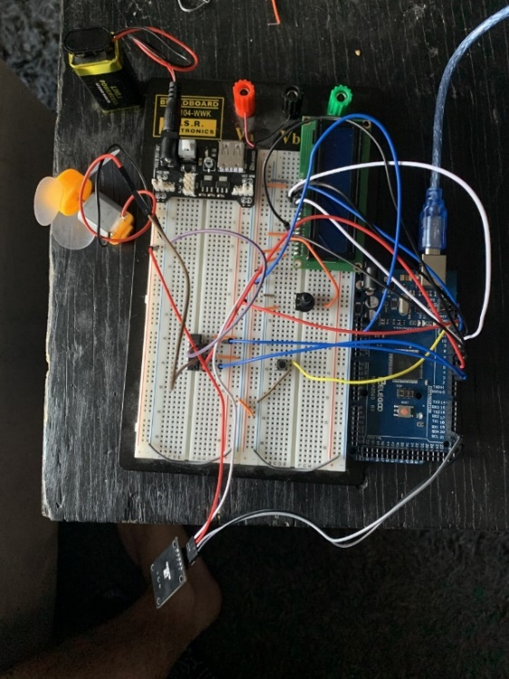

circuit diagram:

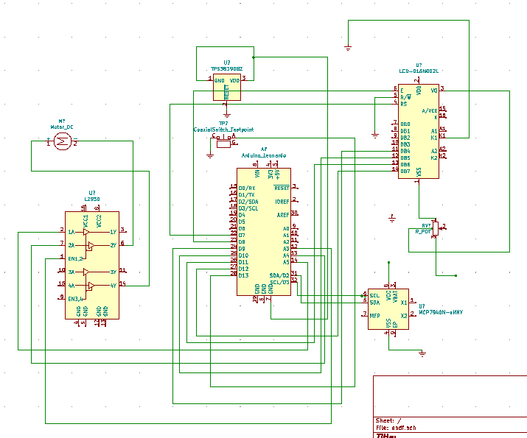

Explanation:

The Arduino connects to L293D, LCD, DS1307, Switch, Power supply and DC Motor. By running the program for fan controller, it can operate as the fan controller and showing the information such as speed, time, and fan directions.

**1.2 Software Design**

**GitHub URL:**

<https://github.com/Kylepurcell10/MicroprocessorsII/tree/main/Lab2>

The GitHub URL contains a public repository that holds the most up to date folder of Lab3 that includes the .ino file and an image of the circuit.

**Pin Assignments:**

Pin 13 is assigned to the button,

Pins 6-11 are assigned to the LCD display

Pin 5 is assigned to the enable of the L293D

Pin 4 is assigned to the clockwise fan direction (pin 2 of the L293D)

Pin 3 is assigned to the counterclockwise fan direction (pin 7 of the L293D)

the SDA and SCL pins are being utilized by the RTC(real time clock) in order for the Arduino to read the information from it.

Additionally the DC source is being used to apply a voltage to rails of the breadboard with a value of 5V or 3V respectively.

Explanation:

The button is used to indicate to the Arduino that the user wants the fan to change directions, pins 6-11 are used to print the time to the LCD display, pin 5 is the enable of the L293D. This essentially acts as a switch between the clockwise input(pin 4) and the counterclockwise input (pin 3). Additionally, all of the components are getting power from the DC power source that is powered by a 9V battery. Finally, the RTC is connected to the SDL and SCL of the Arduino in order to acquire data from the serial port.

**Flow Diagram:**

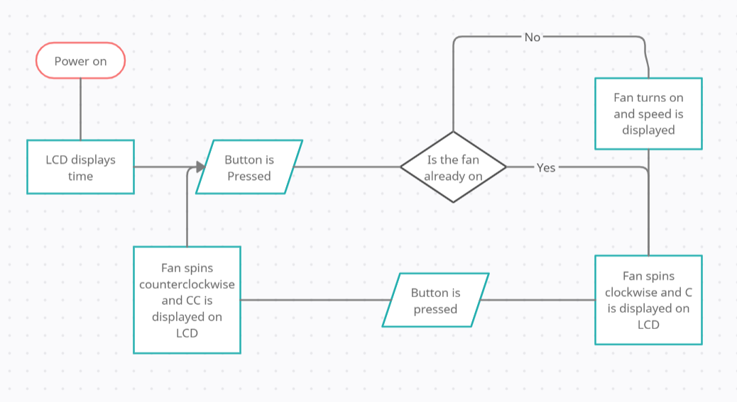

**1.3 Results**

brief explanation: The circuit functioned properly, and fan controller worked well by the user setting.

video link: <https://youtu.be/X-F0YqGLlDU>

extra link: <https://youtu.be/iPpDMskWCG0>

**2. Problem Encountered and Solved**

**3. Personal Contribution to the Lab**

Sua Jung

: Wrote the initial arduino code, debugged the final code, made circuit diagram with KiCad

Julie Dawley

: Debugged and developed the final code, constructed the circuit.

Kyle Purcell

: Wrote some of the Arduino code, recorded the photo and video.

**4. Lessons Learnt**

We could understand to make the controller for a fan with DC motor and Arduino programming to complete the fan controller. Using Arduino was helpful to understand the overall flow of the program and how the microcontrollers work all together in the fan controller system. Constructing the circuit diagram to use the components were useful to build the fan controller and also constructing its own system.